**Name and Student ID: Riley Lawson Lab Section: 6**

**Date: 9/9/2020**

**PRELAB:**

**Q1.** Read section 3.0 and fill in the truth table below for Design 1 (*the farmer’s problem*). Then use it to construct the POS expression.

|  |  |  |  |
| --- | --- | --- | --- |
| **Cabbage** | **Goat** | **Wolf** | **Alarm** |
| 0 | 0 | 0 | 1 |
| 0 | 0 | 1 | 1 |
| 0 | 1 | 0 | 0 |
| 0 | 1 | 1 | 1 |
| 1 | 0 | 0 | 1 |
| 1 | 0 | 1 | 0 |
| 1 | 1 | 0 | 1 |
| 1 | 1 | 1 | 1 |

POS Logic Expression: (C + !G + W) * (!C + G + !W) = Alarm

**Q2.** Read section 4.0 and fill in the truth table below for Design 2 (*adding the farmer*). Then use it to construct the SOP expressions.

|  |  |  |  |  |
| --- | --- | --- | --- | --- |
| **Farmer** | **Cabbage** | **Goat** | **Wolf** | **Alarm** |
| 0 | 0 | 0 | 0 | 0 |
| 0 | 0 | 0 | 1 | 0 |
| 0 | 0 | 1 | 0 | 0 |
| 0 | 0 | 1 | 1 | 1 |
| 0 | 1 | 0 | 0 | 0 |
| 0 | 1 | 0 | 1 | 0 |
| 0 | 1 | 1 | 0 | 1 |
| 0 | 1 | 1 | 1 | 1 |
| 1 | 0 | 0 | 0 | 1 |
| 1 | 0 | 0 | 1 | 1 |
| 1 | 0 | 1 | 0 | 0 |
| 1 | 0 | 1 | 1 | 0 |
| 1 | 1 | 0 | 0 | 1 |
| 1 | 1 | 0 | 1 | 0 |
| 1 | 1 | 1 | 0 | 0 |
| 1 | 1 | 1 | 1 | 0 |

Canonical SOP Logic Expression: !F!CGW + !FCG!W + !FCGW + F!C!G!W + F!C!GW + FC!G!W = Alarm

Simplified SOP Logic Expression: F!C!G + !FGW + F!G!W + !FCG = Alarm

**LAB:**

**3.0** Hardware results demonstrate correct code. TA Initials:

Schematic screenshot:

Step 0:

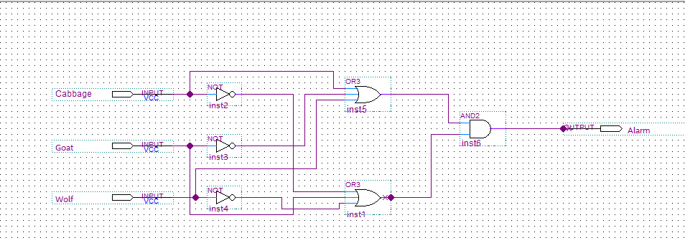

Step3: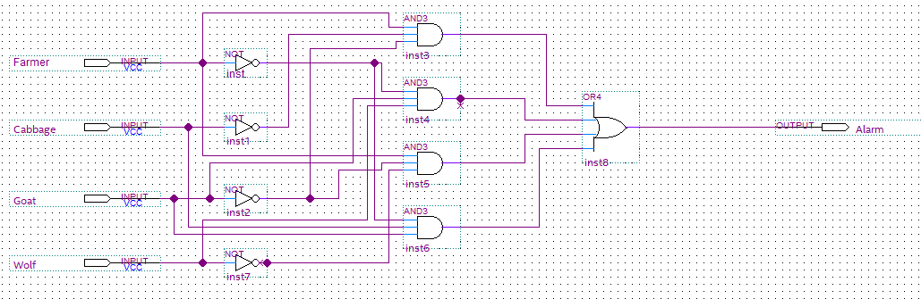

Structural Screenshots:

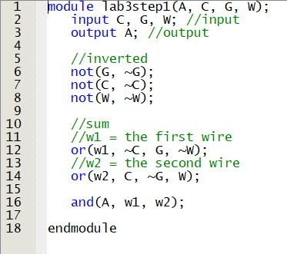

Behavioral Screenshots:

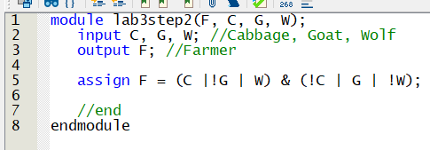

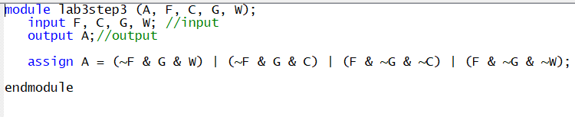

**4.0** Hardware results demonstrate correct code.

Screenshot:

Step 1:

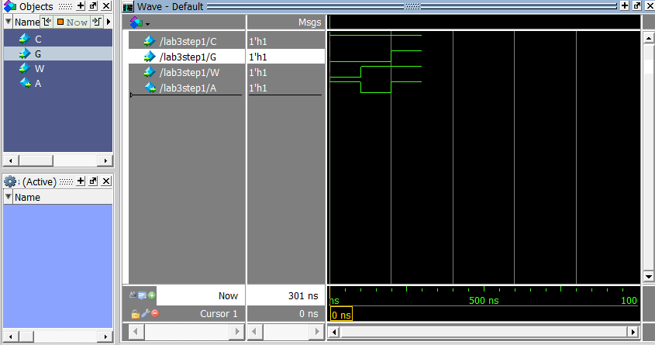

Step 3:

